BSCS FINAL PROJECT
Software Design Specification

Job Fiesta



Project Advisor
Saira Latif

Presented by:
Group ID: F24SE076
Student Reg# Student Name

L1F21BSSE0270 S Muhammad Ali

L1F21BSSE0457 Rehan Sajid

L1F21BSSE0546 Muhammad Furqam

Faculty of Information Technology
University of Central Punjab

Software Design Specification SDP Phase II
Vivid estate-Your Path to Real Residence
Advisor: Saira Latif

Group ID: F24SE076

Member Name | Primary Responsibility
S Muhammad Ali
Rehan Sajid
Muhammad Furqam

Table of Contents
Table of Contents i
Revision History ii
Abstract iii
- Introduction 1
  - Product 1
  - Background 1
  - Objective(s)/Aim(s)/Target(s) 1
  - Scope 2
  - Business Goals 2
  - Document Conventions 3
  - Miscellaneous 3
- Overall Description 3
  - Product Features 3
  - Functional Description 4
  - User Classes and Characteristics 5
  - Design and Implementation Constraints 5
  - Assumptions and Dependencies 6
    - Assumptions 6
    - Dependencies 6
- Technical Architecture 8
  - Application and Data Architecture 8
  - Component Interactions and Collaborations 13
  - Design Reuse and Design Patterns 17
  - Technology Architecture 17
- Screenshots/Prototype 19
  - Workflow 19
  - Screens 20
- Other Design Details 27
- Revised Project Plan 27
- References 28
Appendix A: Glossary 29
Appendix B: IV & V Report 31

Revision History

Name | Date | Reason For Changes | Version

Abstract

Job Fiesta is an AI-powered job matching platform designed to revolutionize the job search process by efficiently connecting job seekers with recruiters. The platform addresses the need for organized solution that streamlines the job search process, reduces the time and effort required to find suitable candidates, and enhances the overall job search experience.
The problem lies in the traditional job search process, which often relies on manual resume screening, inefficient communication channels, and limited candidate recommendations. Job Fiesta solves this problem by offering a comprehensive platform that combines personalized job recommendations, automated resume generation, a built-in chatting feature, and a rating system for job seekers based on their communication skills and professionalism.
The platform also features a recommendation system for recruiters to find suitable candidates, ensuring that job seekers are matched with relevant job opportunities. By leveraging machine learning algorithms, Job Fiesta creates a community-driven platform where job seekers and recruiters can interact, share information, and provide feedback on the job search process.
Key knowledge areas applied in the development of Job Fiesta include artificial intelligence, machine learning, web development, user experience design, and data analytics. The expected result is a useful, collaborative platform that meets the needs of both job seekers and recruiters, offering a hassle free job search experience and improving the overall efficiency of the job market.

Introduction

Product

In the traditional job search and recruitment landscape, job seekers often struggle with static job postings and manual resume submissions, which fail to effectively connect them with potential employers. This disjointed process can lead to wasted time and frustration, as candidates sift through numerous listings that may not align with their skills or preferences. Additionally, the lack of efficient communication channels between job seekers and recruiters can result in misunderstandings and missed opportunities.

Job Fiesta addresses these challenges by providing an AI-powered job matching platform designed to streamline the recruitment process. The platform allows job seekers to create tailored resumes, receive personalized job recommendations based on their profiles, and engage in real-time chat with recruiters. For recruiters, Job Fiesta offers tools to post job openings, evaluate candidates based on their communication skills, and provide ratings for job seekers. By fostering a transparent and efficient environment, Job Fiesta enhances the overall job search experience, making it easier for job seekers to find suitable employment and for recruiters to identify qualified candidates.

Background

The background of Job Fiesta is rooted in the evolving landscape of employment and recruitment,
where traditional job search methods are increasingly being supplemented by digital solutions. With
the rise of remote work and the gig economy, job seekers are looking for more flexible and accessible ways to find employment opportunities that match their skills and preferences. Simultaneously, employers are facing challenges in identifying and attracting the right talent.

Job Fiesta aims to bridge this gap by providing a comprehensive online platform that caters to both
job seekers and employers. By harnessing the power of technology, Job Fiesta offers a centralized
market place where candidates can showcase their qualifications and experiences while employers
can efficiently manage their hiring processes. This background highlights the need for a modern
solution that not only simplifies the job search experience but also fosters a vibrant community of
professionals and organizations dedicated to career growth and development.

Objective(s)/Aim(s)/Target(s)

The primary objective of Job Fiesta is to create an AI-powered job matching platform that
simplifies the job search process, provides personalized job recommendations, and
facilitates efficient communication and assessment between job seekers and recruiters.

The specific aims of Job Fiesta are:

- To develop a comprehensive platform that integrates key job search functionalities, such as personalized job recommendations, automated resume generation, a built-in chatting feature, and a rating system for job seekers.

- To provide a seamless and efficient job search experience for job seekers, reducing the time and effort required to find suitable job opportunities.

- To offer recruiters a platform that helps them find suitable candidates quickly, reduces the time and effort required to screen resumes, and provides a more accurate assessment of a candidate's skills and fit.

- To create a community-driven platform where job seekers and recruiters can interact, share information, and provide feedback on the job search process.

- To improve the overall efficiency and effectiveness of the job market, making it easier for job seekers to find employment and for recruiters to find the right candidates.

Scope

The Job Fiesta platform serves as a comprehensive digital marketplace designed to facilitate the connection between job seekers and employers across various industries. The scope of JobFiesta covers a wide range of functionalities, including job postings, resume uploads, application tracking, and employer reviews. Targeting both entry-level candidates and seasoned professionals, the platform aims to cater to diverse job markets, including full-time, part-time, and freelance opportunities.
Job Fiesta's reach is intended to be global, allowing users from different geographical locations to access job opportunities and talent pools. Additionally, the platform promotes inclusivity by supporting various industries and job types, ensuring that all users, regardless of their background or experience level, can benefit from its services. By promoting a user-friendly environment, Job Fiesta aims to enhance the overall recruitment experience while encouraging networking and professional development within the job-seeking community.

Business Goals
JobFiesta aligns with several key business goals, including:
- Enhancing User Engagement and Retention: Foster a dynamic user experience that encourages job seekers and employers to return to the platform regularly through personalized features and ongoing support.
- Market Expansion: Broaden the platform's reach by targeting diverse industries and geographical locations, ensuring a wide array of job opportunities and talent.
- Employer Trust and Quality Assurance: Establish a reputation for reliability by implementing verification processes for employers and providing transparent feedback mechanisms for job seekers.
- Data Security and Compliance: Ensure the protection of user data through robust security measures and adherence to relevant regulations, fostering trust among users.
- Attracting Potential Employers and Job Opportunities: Create a compelling value proposition for employers to post job openings, highlighting the platform's effectiveness in connecting them with qualified candidates.
- Partnerships with Educational Institutions and Training Programs: Collaborate with universities, vocational schools, and training organizations to provide users with access to skill development resources and job placement services.
- Building a Thriving Community of Professionals: Encourage networking and collaboration among users through forums, events, and mentorship programs, enhancing the overall job-seeking experience.
- Continuous Improvement and Innovation: Regularly update the platform with new features and enhancements based on user feedback and industry trends to maintain competitiveness.
- Providing Value-Added Services to Users: Offer additional resources such as career coaching, resume writing services, and interview preparation to support users in their job search journey.

Document Conventions
In this SDS document we bold text that is important. Heading is used to make our document much more organized. Abbreviation of word is described in closed parenthesis next to it.

Miscellaneous
We can use project management tools to manage our project. We will set up a project What’s app group for urgent matters and quick updates. We will maintain a project wiki to document project progress, decisions, and knowledge. We will give each member in our team different Roles and Responsibilities, We will set milestones and deadlines for each task and phase of the project.

Overall Description

Product Features
Job Fiesta encompasses a range of major features, including but not limited to:
- User Profiles: Job seekers and employers can create comprehensive profiles that highlight skills, experiences, job preferences, and company culture, enhancing visibility and matching accuracy.
- Job Posting and Application Management: Employers can easily post job openings, manage applications, and track candidate progress through an intuitive dashboard, while job seekers can apply for jobs and monitor their application status.
- Advanced Search and Filtering: Job seekers can utilize advanced search options to find job listings that match their skills and preferences, while employers can filter candidates based on specific criteria.
- Personalized Job Recommendations: The platform uses algorithms to suggest job listings to seekers based on their profiles, search history, and preferences, ensuring they find relevant opportunities.
- Networking Opportunities: Job Fiesta facilitates networking by allowing users to connect with industry professionals, join groups, and participate in discussions, fostering community engagement.
- Employer Reviews and Ratings: Job seekers can read and leave reviews for employers based on their experiences, promoting transparency and helping candidates make informed decisions.
- Mobile Compatibility: Job Fiesta is optimized for mobile devices, allowing users to search for jobs, apply, and manage their profiles on the go.

Functional Description
- User Registration and Profile Creation: Users can easily register on the platform by providing essential personal information such as their name, email address, and password. Once registered, users can create and update their profiles with additional details, including work experience, education, and skills, enhancing their visibility to potential employers.
- Post a Job Listing: Employers have the ability to create job listings by filling out a user-friendly form that includes key information such as job title, description, requirements, and salary. The system allows employers to edit or delete their job listings as needed, ensuring that job postings remain current and accurate.
- Apply for Jobs: Job seekers can browse through a comprehensive list of job listings and submit applications directly through the platform. The application process is streamlined to include the option to upload a resume and a cover letter, making it easy for candidates to present their qualifications to potential employers.
- Resume Generation: The platform provides users with tools to create and customize their resumes using a variety of templates. Users can easily download their resumes in multiple formats, such as PDF and Word, allowing for flexibility in how they present their qualifications to employers.
- View Personalized Job Recommendations: The system analyzes user profiles and preferences to suggest relevant job opportunities tailored to each job seeker. Users can view and filter these personalized recommendations based on their interests and qualifications, enhancing their job search experience.
- View Applications: Job seekers can track the status of their job applications in a dedicated section of the platform. The system displays important details such as the application date, current status, and any feedback provided by employers, keeping users informed throughout the application process.
- Chat Between Users: The platform facilitates real-time chat functionality, allowing job seekers and employers to communicate directly for inquiries and discussions. Users can initiate and manage conversations within their profiles, promoting efficient communication and engagement.
- Provide Feedback: Users have the opportunity to submit feedback regarding their experiences with job applications and the platform itself. The system allows users to rate their experiences and provide comments for improvement, fostering a culture of continuous enhancement and user satisfaction.

User Classes and Characteristics
Job Seekers

Characteristics:
    - Individuals actively looking for employment opportunities across various industries.
    - May include recent graduates, experienced professionals, or those seeking career changes.
    - Varying levels of technical proficiency, from novice users to tech-savvy individuals.
    - Motivated by factors such as salary, job satisfaction, career growth, and work-life balance.
Requirements:
    - Access to a wide range of job listings that match their skills and preferences.
    - Tools for creating and managing their profiles and resumes.
    - Resources for interview preparation and career development.
    - Networking opportunities to connect with potential employers and industry professionals.

Recruiters
Characteristics:
- Companies, organizations, or third-party recruitment agencies looking to hire talent for various positions.
- May range from small businesses to large corporations across different sectors.
- HR professionals, hiring managers, or independent recruiters responsible for recruitment.
Requirements:
- A platform to post job openings and manage applications efficiently.
- Access to a pool of qualified candidates with diverse skills and experiences.
- Tools for filtering and evaluating candidates based on specific criteria.
- Insights into employer branding and candidate feedback to improve hiring practices.

Administrators
Characteristics:
- Individuals responsible for managing the JobFiesta platform, including technical support and user management.
- May include IT professionals, customer support staff, and content managers.
Requirements:
- Tools for monitoring platform performance and user activity.
- Capabilities for managing user accounts, job postings, and content moderation.
- Access to analytics and reporting features to assess platform usage and effectiveness.

Design and Implementation Constraints

When developing the Job Fiesta platform, several design and implementation constraints must be considered to ensure the system is effective, user-friendly, and scalable. These constraints include:
1. Technical Constraints
- Platform Compatibility: The website must be compatible with various web browsers (e.g., Chrome, Firefox, Safari) and mobile devices (iOS and Android) to ensure accessibility for all users.
- Scalability: The architecture must support scalability to handle an increasing number of users and job postings without compromising performance.
- Integration with Third-Party Services: The platform may need to integrate with third-party services (e.g., payment gateways, social media platforms, and background check services), which can introduce additional complexity.
2. Security Constraints
- Data Privacy: Compliance with data protection regulations (e.g., GDPR, CCPA) is essential to protect user information and ensure that personal data is handled responsibly.
- User Authentication: Robust authentication mechanisms (e.g., two-factor authentication) must be implemented to secure user accounts and prevent unauthorized access.
- Data Encryption: Sensitive data, such as user profiles and payment information, must be encrypted both in transit and at rest to safeguard against data breaches.
3. Usability Constraints
- User Experience (UX) Design: The platform must be designed with a focus on user experience, ensuring that navigation is intuitive and that users can easily find job listings or manage their profiles.
- Accessibility Standards: The website should adhere to accessibility standards (e.g., WCAG) to ensure that it is usable by individuals with disabilities.
4. Resource Constraints
- Budget Limitations: The development and maintenance of the platform must stay within budget constraints, which may limit the scope of features and functionalities.
- Time Constraints: Project timelines must be adhered to, which can impact the development process and the implementation of certain features.
5. Regulatory Constraints
- Employment Laws: The platform must comply with relevant employment laws and regulations in the regions it operates, which may affect job postings and recruitment practices.
- Advertising Standards: Adherence to advertising standards and guidelines is necessary to ensure that job postings are accurate and not misleading

Assumptions and Dependencies

Assumptions
- User Internet Access: Users have reliable internet access to browse and utilize the platform effectively.
- Market Demand: There is a consistent demand for job postings and recruitment services online.
- Legal Compliance: The platform will adhere to local and international laws regarding employment, data protection, and e-commerce.
- Job Posting Accuracy: Employers will provide accurate and truthful information about job openings and requirements.
- User Trust: Users trust the platform to facilitate secure and fair transactions between job seekers and employers.
- Responsive Design: The website is designed to be user-friendly and accessible across various devices and screen sizes.
- Marketing and User Acquisition: Effective marketing strategies will be implemented to attract both job seekers and employers to the platform.
- Profile Completeness: Job seekers will maintain complete and updated profiles to enhance their visibility to potential employers.

Dependencies

- Technology Infrastructure: Reliable hosting services and a stable internet connection are essential for the platform's operation.
- Legal and Regulatory Compliance: The platform must comply with employment laws and data protection regulations in the regions it serves.
- User Verification: A system for verifying the identity of users will be implemented to build trust on the platform.
- Job Inventory Management: A system for managing and updating job listings to ensure accuracy and relevance.
- Photography and Description: Employers will provide clear and accurate descriptions of job roles and company culture.
- Security Measures: Implementing security measures to protect user data, including encryption and secure login systems.
- Marketing Strategy: Developing and executing an effective marketing strategy to attract users to the platform.
- Feedback and Reviews: Establishing a system for collecting and displaying user feedback and reviews to enhance credibility.
Technical Architecture

Application and Data Architecture

ER Diagram:

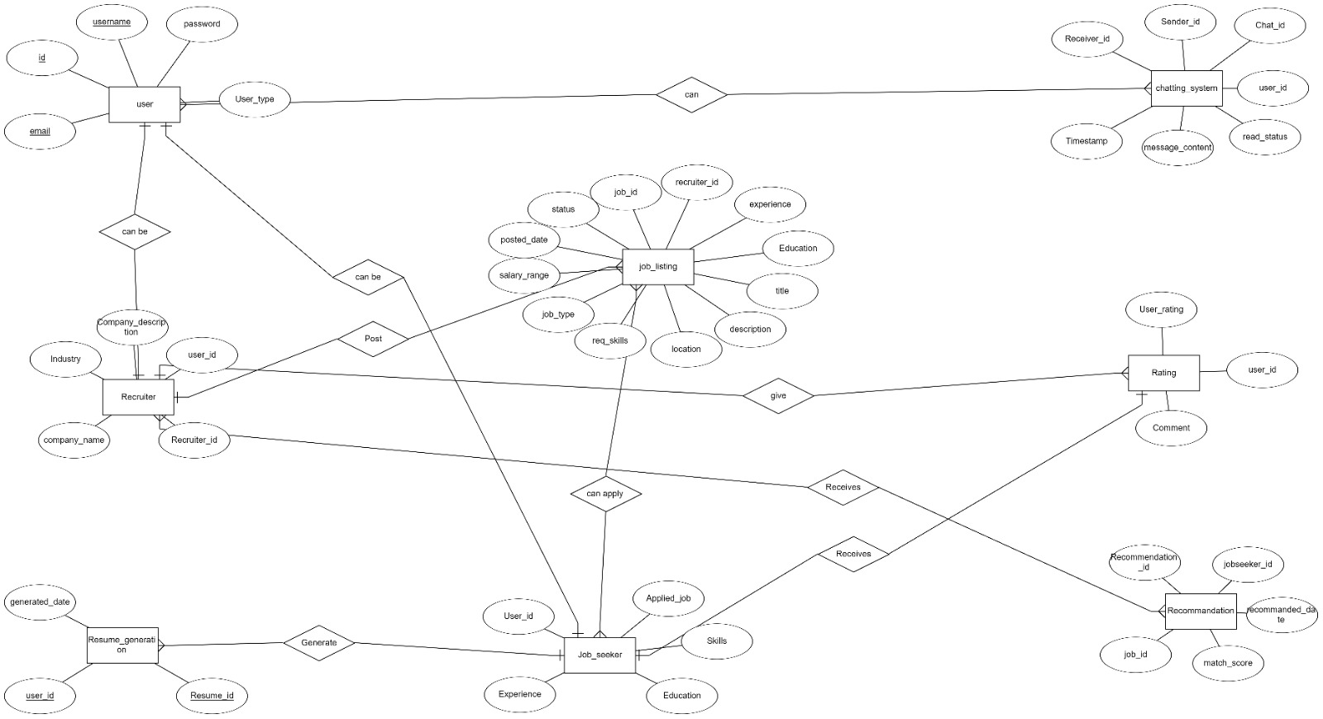

Figure 1 - ER diagram for the whole system and relationship between entities

Class Diagram:
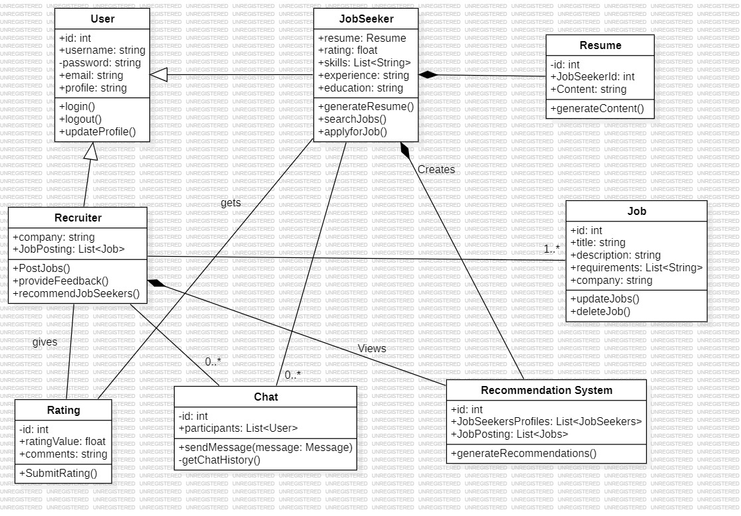

Figure 2 - Class Diagram for all the objects in the system

Sequence Diagrams:

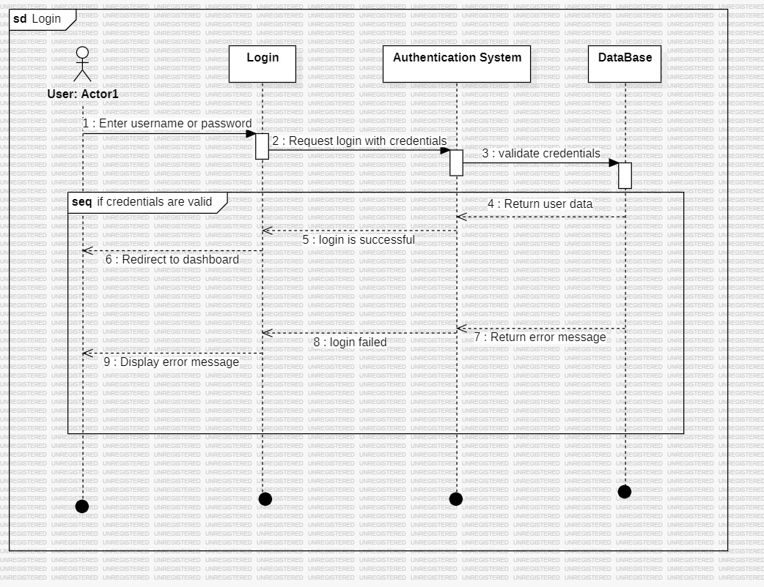

Figure 3.1 - Sequence diagrams of Login System
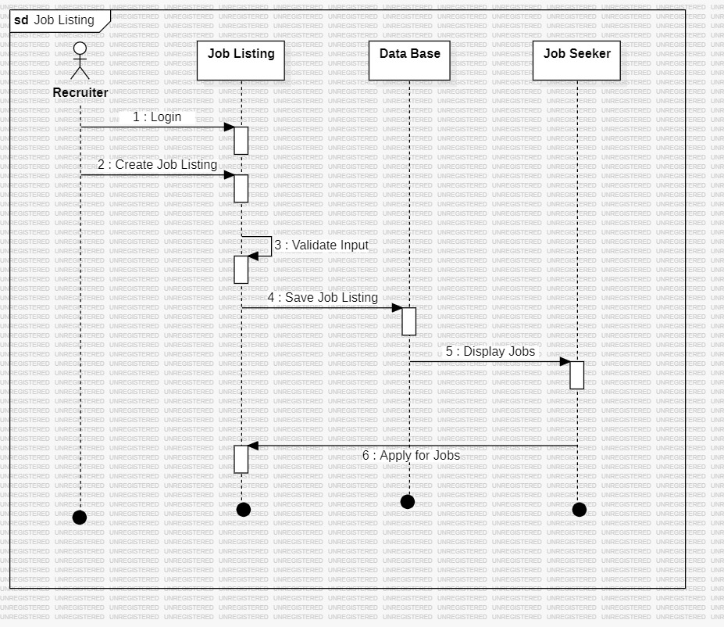

Figure 3.2 - Sequence diagrams for Job listings
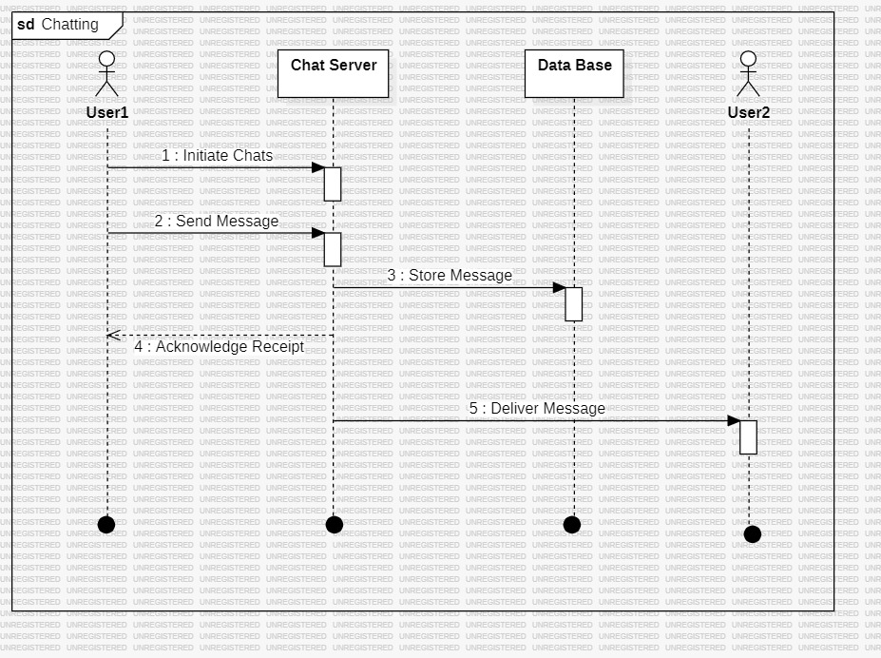

Figure 3.3 - Sequence diagrams of Chatting between users
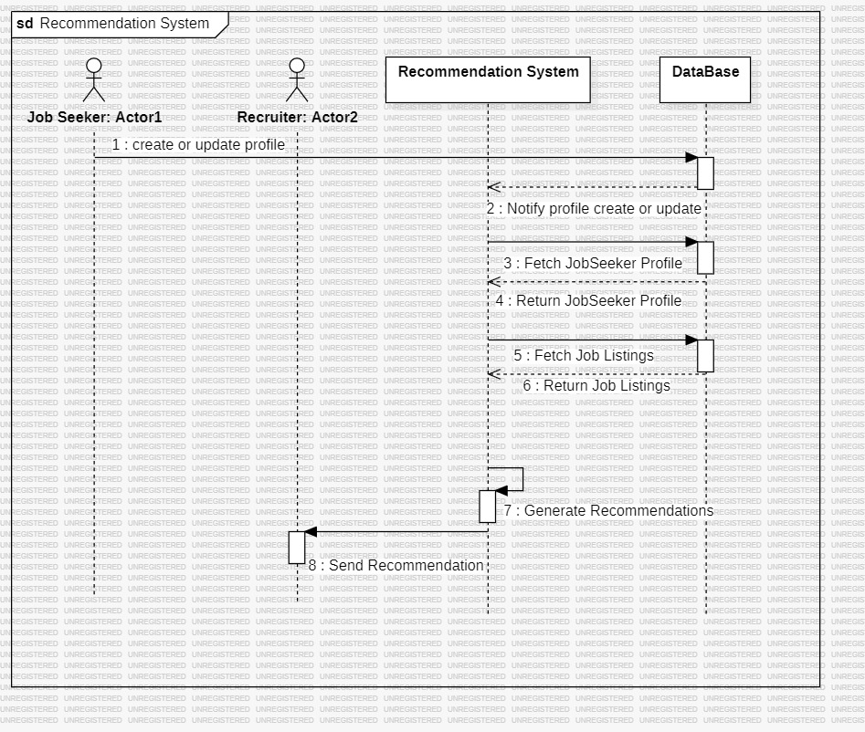

Figure 3.4 - Sequence diagrams of Recommendation System
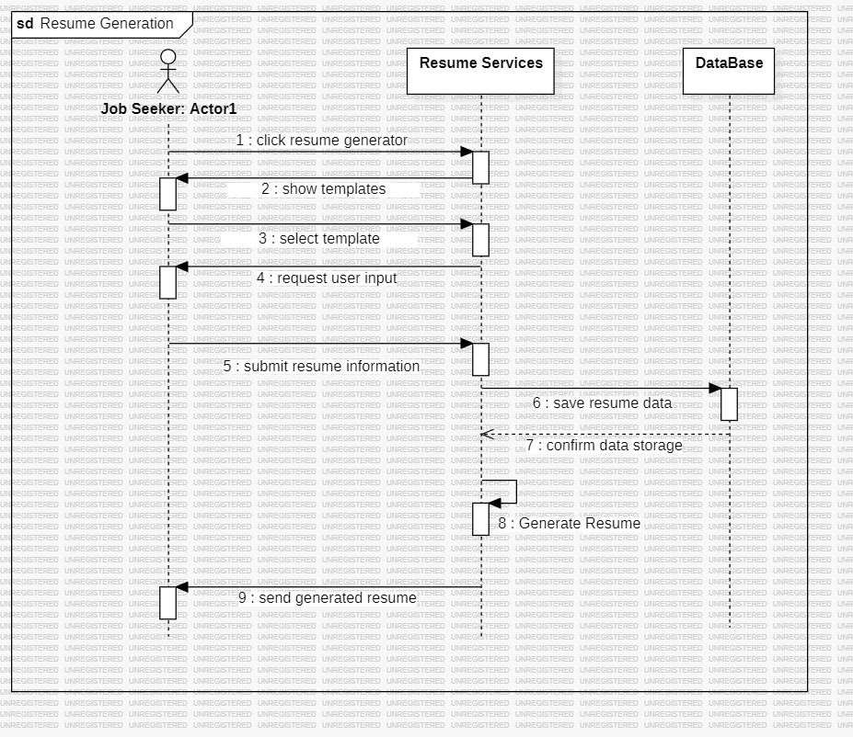

Figure 3.5 - Sequence diagrams for Resume Generation

Collaborative Diagram:
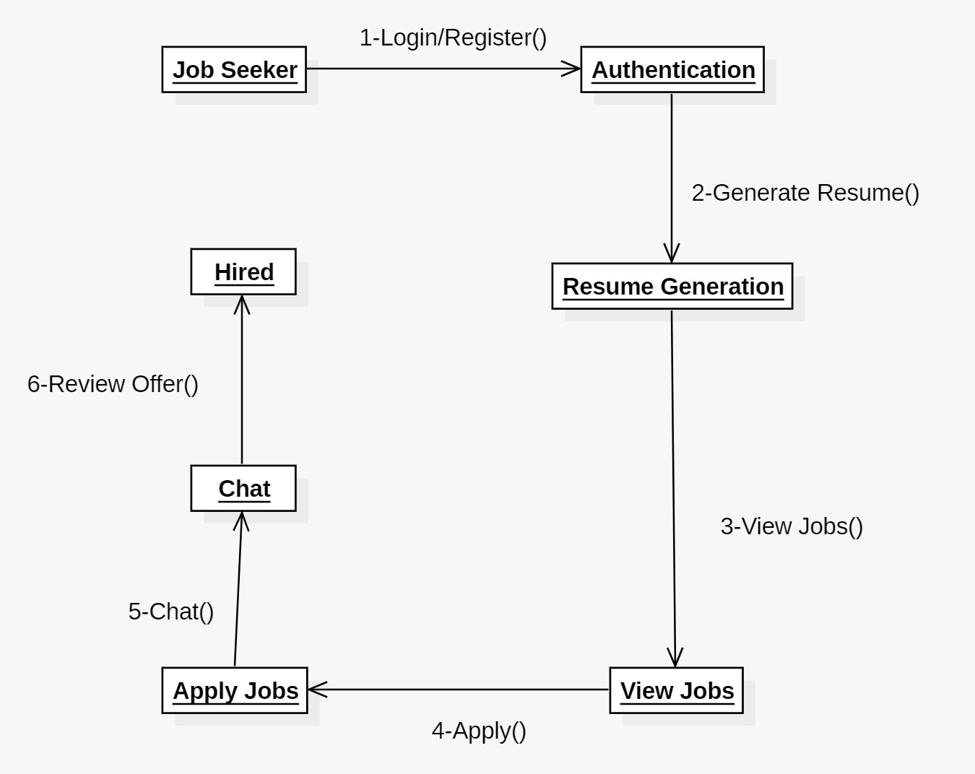
Figure 4.1 - Collaborative diagram for Jobseeker
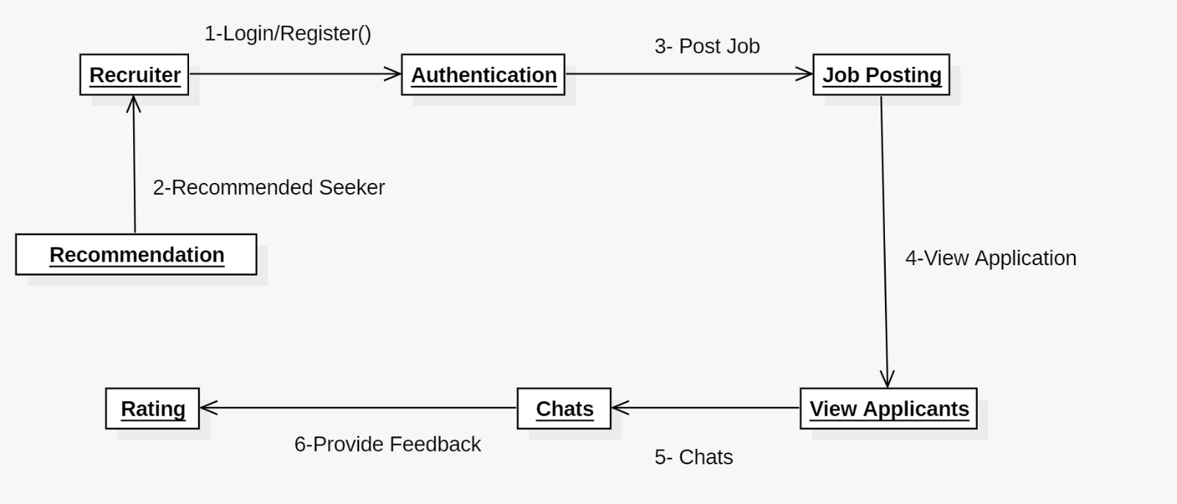
Figure 4.2 - Collaborative diagram for Recruiter

High Level Architecture:
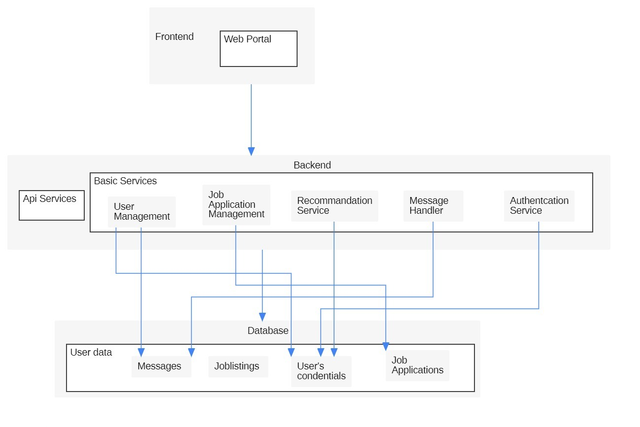
Figure 5 - High Level Architecture of our entire

Gantt Chart:
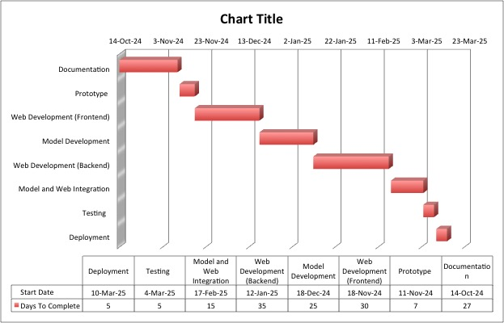
Figure 6 - Gantt chart of our entire tasks.

Component Interactions and Collaborations

DFD Diagram:
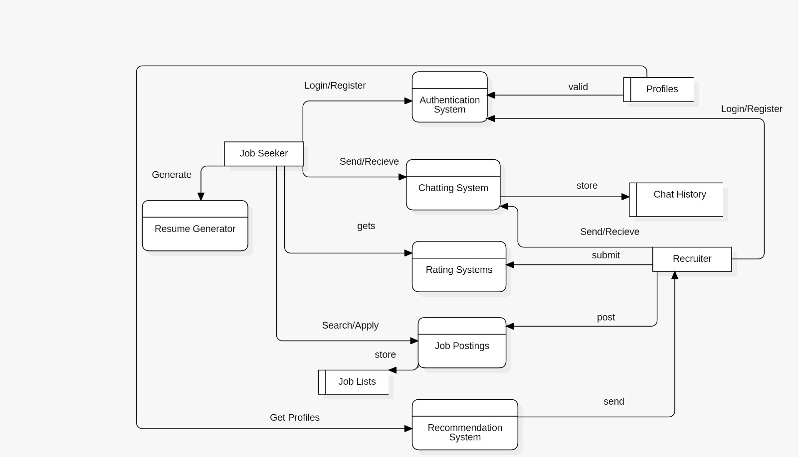
Figure 7 - Data flow diagram for the whole system

Activity Diagram:

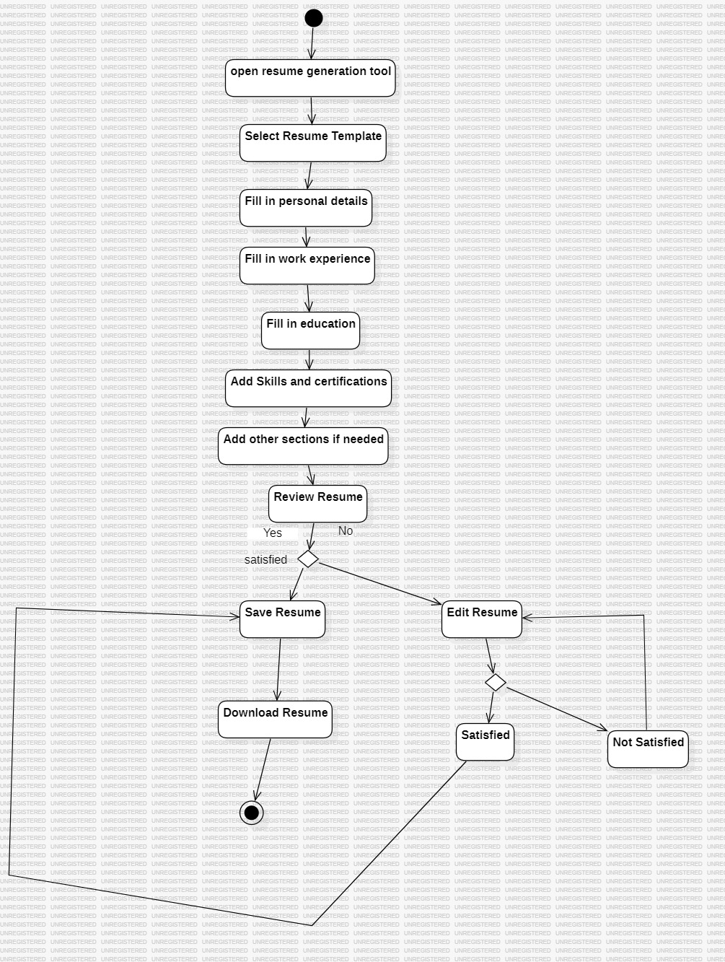

Figure 8.1 - Activity diagram for resume generation
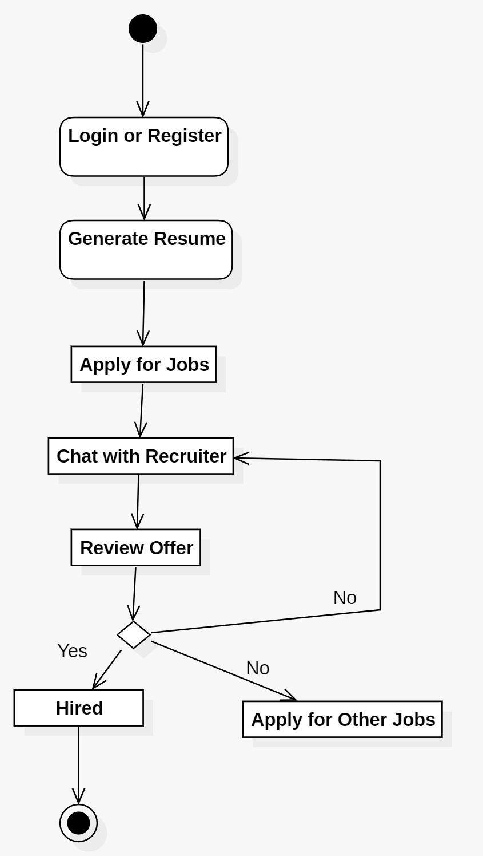
Figure 8.2 - Activity diagram for Job Seeker

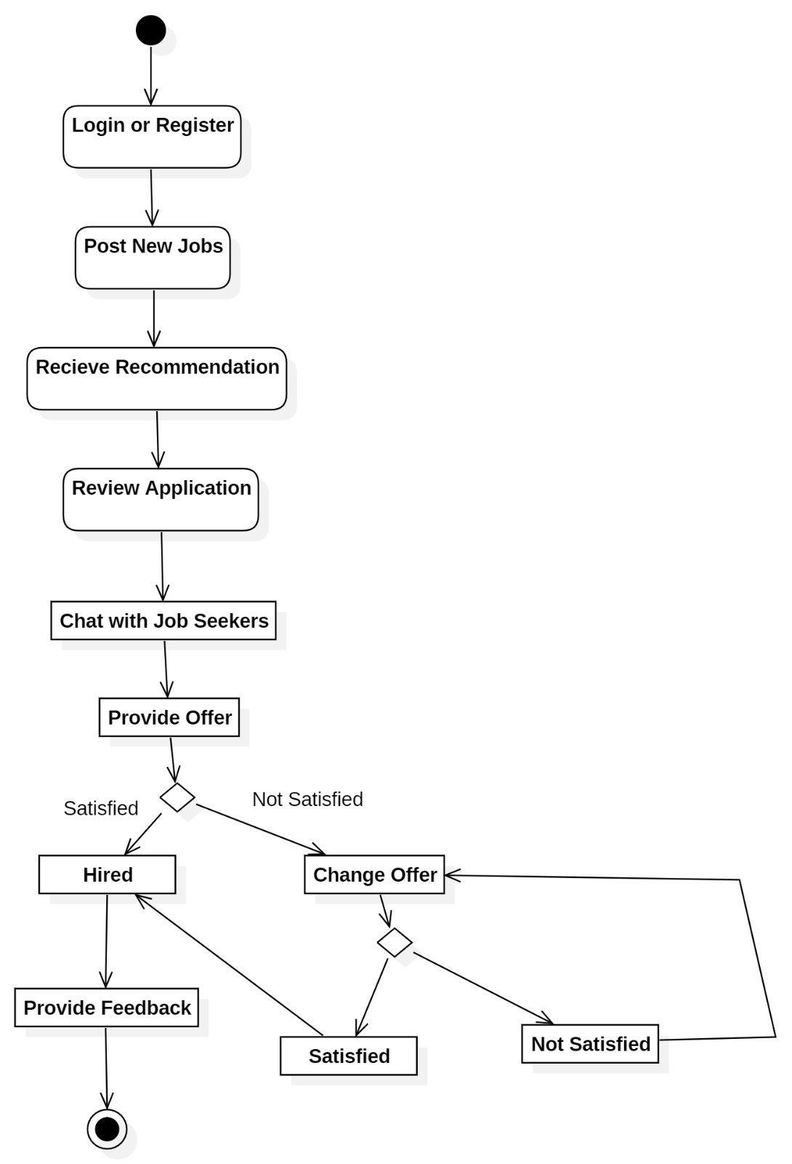
Figure 8.3 - Activity diagram for recruiter

Component Diagram 01:

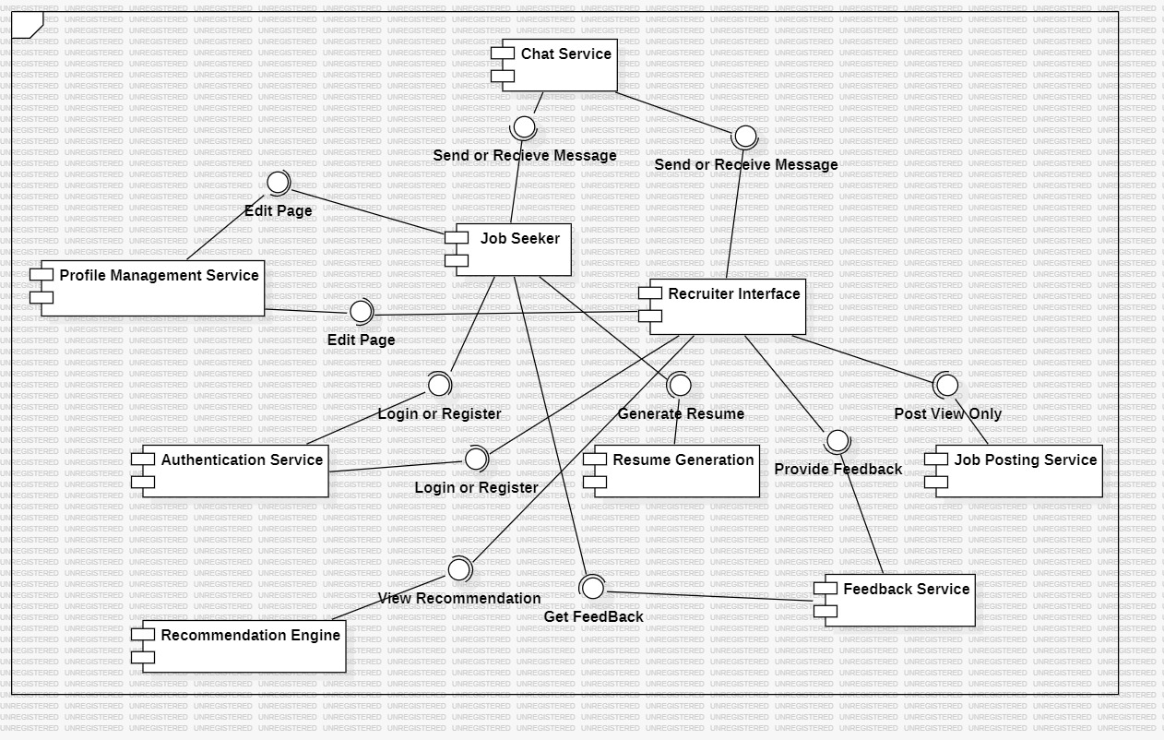

Figure 9 - Component diagram of the entire system

Decision Table:

Rule | User Logged In? | User Type | Profile Complete? | Action Requested | Action
1 | No | Any | _ | Any Access | Redirect to Login Page
2 | Yes | JobSeeker | No | Generate Resume | Prompt Profile Completion
3 | Yes | JobSeeker | Yes | Generate Resume | Create and Download Resume
4 | Yes | JobSeeker | Yes | Apply Job | Submit Job Application
5 | Yes | JobSeeker | No | Apply Job | Redirect to Profile Update
6 | Yes | JobSeeker | Yes | Search Jobs | Display Job Listings
7 | Yes | JobSeeker | Yes | Chat | Enable Chat Interface
8 | Yes | Recruiter | No | Post Job | Redirect to Profile Update
9 | Yes | Recruiter | Yes | Post Job | Create New Job Listing
10 | Yes | Recruiter | Yes | View Applications | Display Applicants List
11 | Yes | Recruiter | Yes | Send Feedback | Submit Feedback Form
12 | Yes | Any | Yes | Update Profile | Save Profile Changes
13 | Yes | Any | _ | Logout | End User Session
14 | Yes | Recruiter | No | JobSeeker | Prompt Profile Completion
15 | Yes | Recruiter | Yes | JobSeeker | Submit Rating

Design Reuse and Design Patterns
- Singleton Pattern for User Session Management: Reuse is evident in the implementation of the Singleton pattern for managing user sessions. This design choice ensures that there is a single, globally accessible instance responsible for handling user authentication and session data. By employing the Singleton pattern, the platform prevents conflicts related to multiple session instances, providing a consistent and efficient user experience.
- Observer Pattern for Real-Time Chat Notifications: Reuse is observed in the application of the Observer pattern for managing real-time chat notifications between job seekers and recruiters. This design establishes a one-to-many dependency, allowing multiple users to receive updates about new messages or changes in chat status. The Observer pattern enhances communication within the platform, ensuring that users are promptly informed without the need for continuous polling.
- Strategy Pattern for Job Recommendation Algorithms: Reuse is identified in the use of the Strategy pattern for implementing various job recommendation algorithms. This design allows the platform to dynamically switch between different recommendation strategies based on user preferences and behavior. By utilizing the Strategy pattern, Job Fiesta can accommodate diverse user needs, providing tailored job suggestions that enhance the job search experience.
- Database Schema Design: Reuse is evident in the thoughtful design of the database schema, which incorporates principles of normalization and modularity. The modular database schema design is reused across various aspects of the system, including user profiles, job listings, applications, and chat interactions. This design choice supports efficient data storage and retrieval while anticipating future expansion needs, ensuring that the platform can scale effectively as the user base grows.

Technology Architecture
- Platform: The Job Fiesta application will be developed as a cross-platform web application, ensuring compatibility across various devices, including desktops, tablets, and smartphones. The frontend will be built using modern frameworks such as React or Angular, allowing for a responsive and user-friendly interface that provides a seamless experience for both job seekers and recruiters.
- System Hosting: The application will utilize cloud-based hosting services for scalability and reliability. Cloud platforms like Amazon Web Services (AWS) or Google Cloud Platform (GCP) will be considered for hosting the backend infrastructure, including servers, databases, and other necessary resources to support the application's growth and performance.
- Connectivity Requirements: The application will require internet connectivity for various features such as real-time chat, job data retrieval, and application processing. Both Wi-Fi and cellular network connectivity will be supported to ensure accessibility in different environments, allowing users to engage with the platform anytime, anywhere.
- Modes of Operations: The Job Fiesta application will primarily operate in an online mode, providing users with access to real-time features such as job postings, application status updates, and chat functionalities. While offline capabilities may be limited, users will be able to view previously accessed job listings and cached data without an active internet connection.
- Backend Infrastructure: The backend infrastructure will consist of servers running web frameworks like Node.js or Django to handle business logic, data processing, and communication with the frontend. A relational database management system (RDBMS) like PostgreSQL or Mongo DB will be used for storing user profiles, job listings, application details, and chat interactions.
- API Integration: The application will integrate with external APIs to enhance functionality. APIs such as Google Maps API for location-based job searches and third-party authentication services (e.g., LinkedIn, Google) will be utilized to provide additional value to users and streamline the registration process.
- Security Measures: Security protocols like HTTPS will be implemented to ensure secure communication between the application and servers. User authentication mechanisms, including multi-factor authentication (MFA), encryption techniques for sensitive data, and role-based access controls will be employed to protect user information and ensure privacy.

Screenshots/Prototype

Workflow
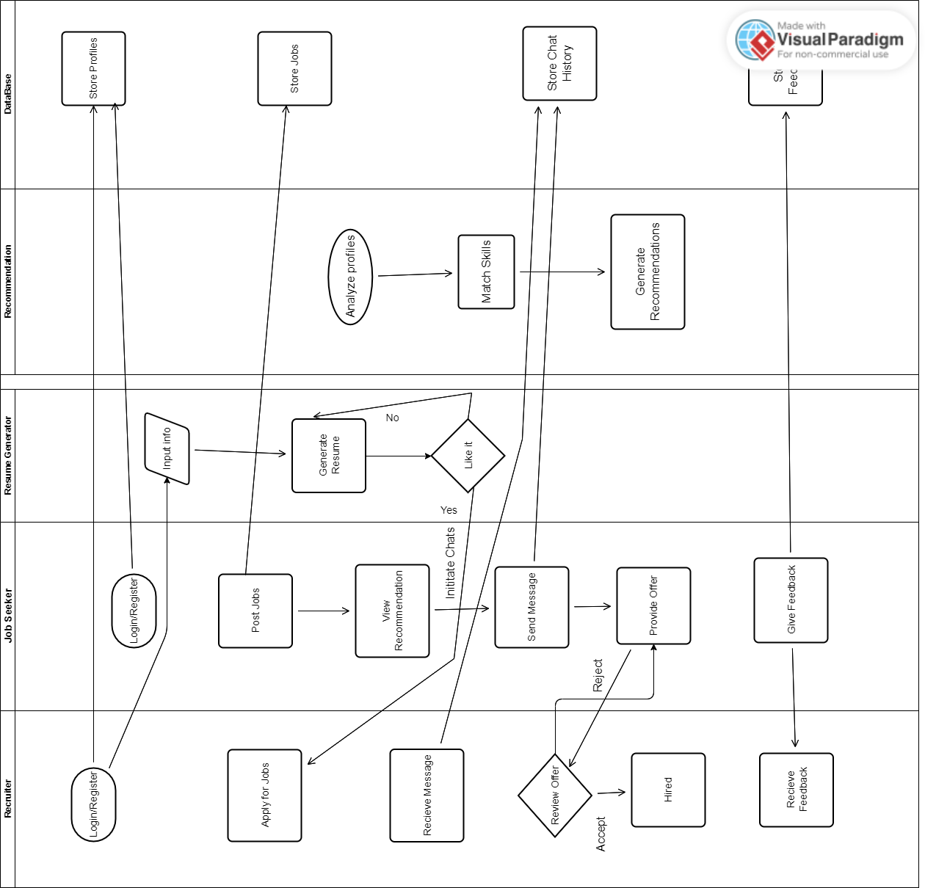
Figure 11 - Swim lane diagram of the whole system workflow

Screens

Login page:

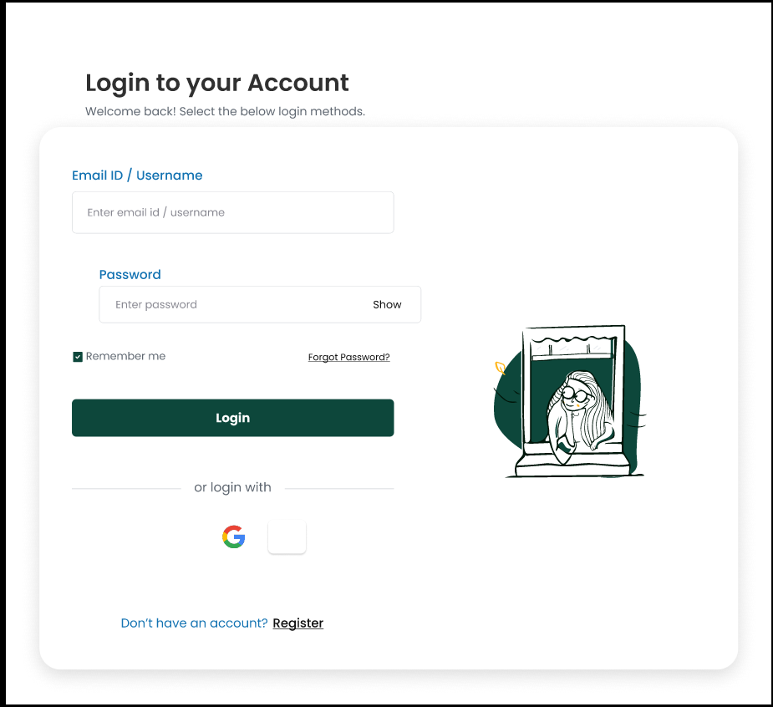


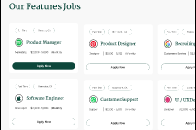


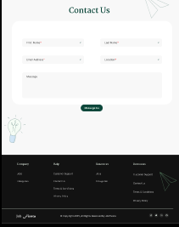

Main Registration Page:

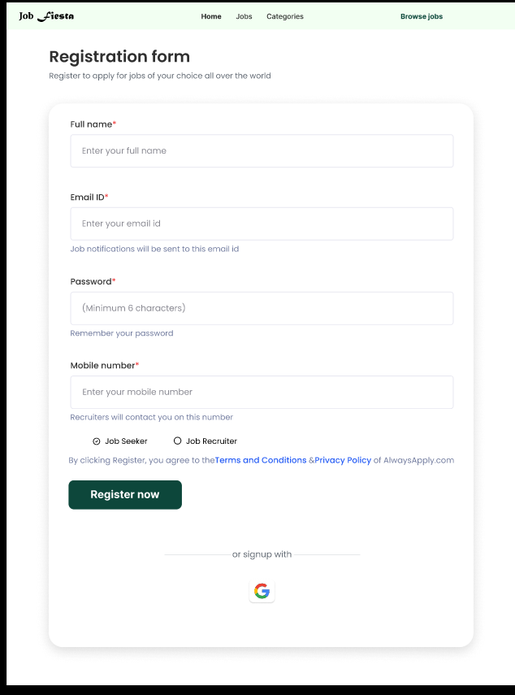

Regisration Page for job seeker:

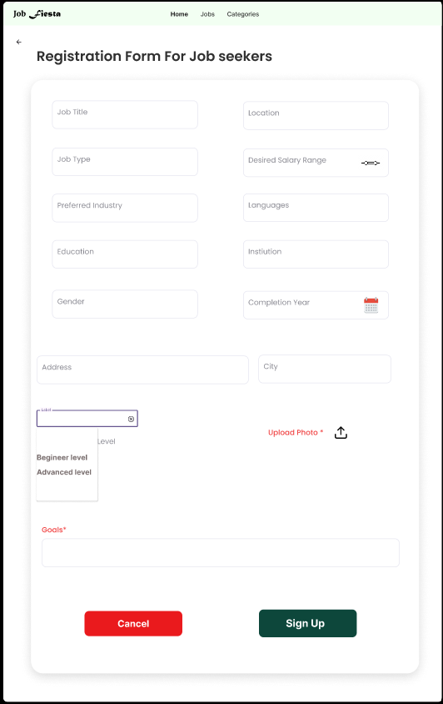

Registration Page for recuiter
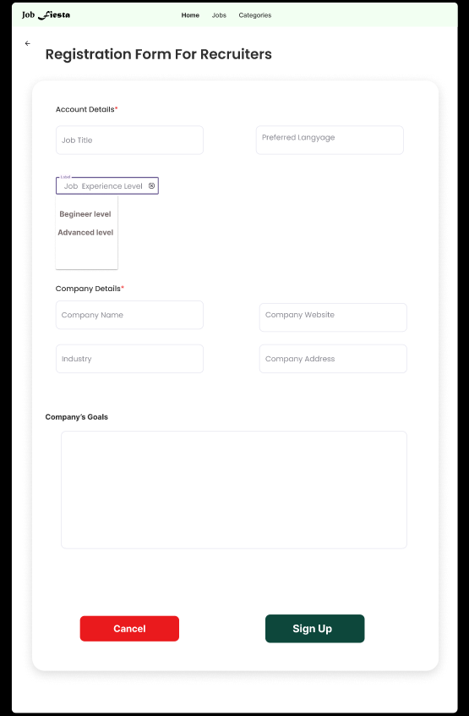

Job search Page:

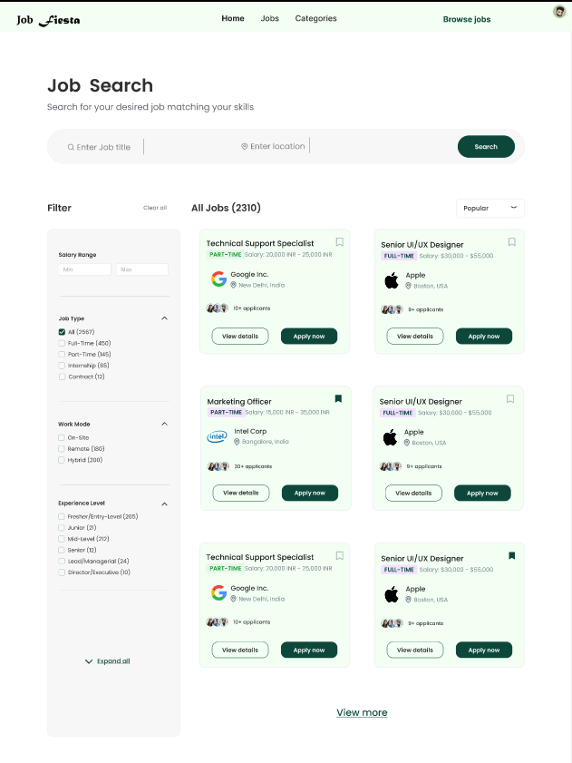

Job Post Page:

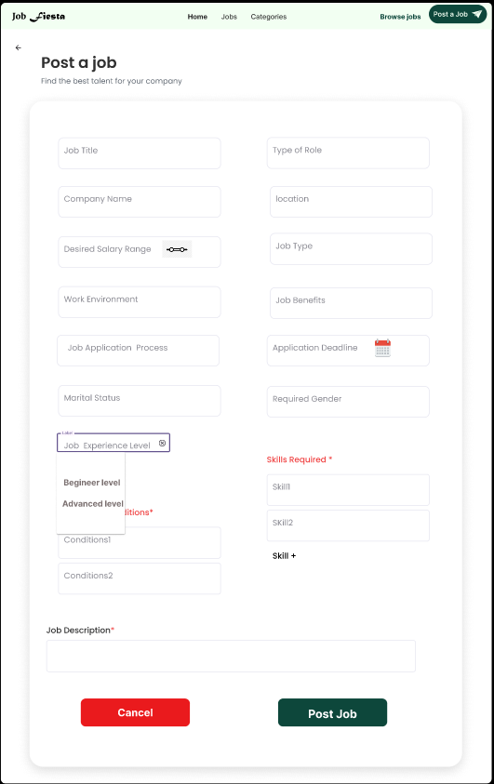

Job search Page for Job Seeker::

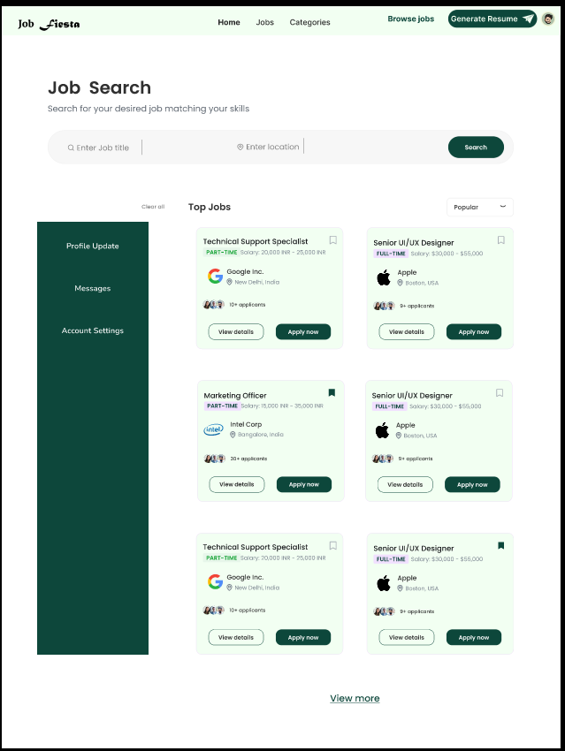

Job Detail Page:

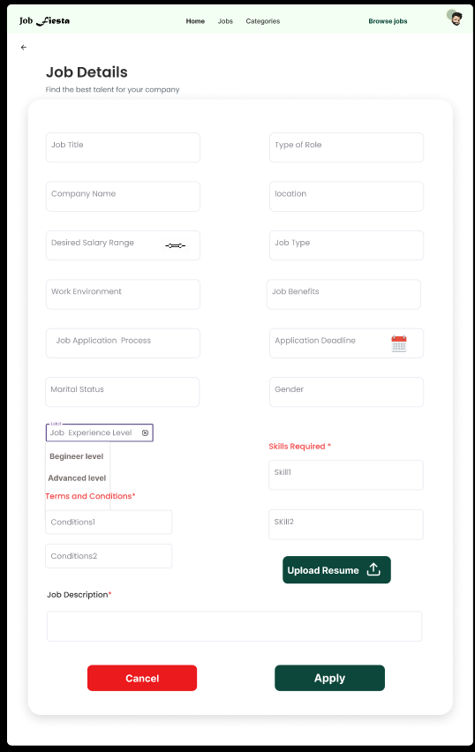

References

- https://www.bayt.com/en/pakistan/
- https://jobee.pk/
- https://resume.io/
- https://rozee.pk/
- https://pk.linkedin.com/
- React. (n.d.). A JavaScript library for building user interfaces. Retrieved from https://reactjs.org
- GDPR.eu. (n.d.). General Data Protection Regulation (GDPR) Compliance Guidelines. Retrieved from https://gdpr.eu
- Gamma, E., Helm, R., Johnson, R., & Vlissides, J. (1994). Design Patterns: Elements of Reusable Object-Oriented Software. Addison-Wesley.
- Shneiderman, B., & Plaisant, C. (2010). Designing the User Interface: Strategies for Effective Human-Computer Interaction. 5th Edition. Pearson.
- Nielsen Norman Group. (2020). User Experience (UX) Research. Retrieved from https://www.nngroup.com

Appendix B: IV & V Report

(Independent verification & validation) IV & V Resource

Name Signature

S# | Defect Description | Origin Stage | Status | Fix Time
 |  |  |  | Hours | Minutes
1
2
3
…

Table 1: List of non-trivial defects

This document has been adapted from the following:

Previous project templates at UCP

High-level Technical Design, Centers for Medicare & Medicaid Services. (www.cms.gov)

